EXPERIMENT 11

180-DEGREE IMAGE ROTATION USING OPENCV

AIM
To rotate the given image by 180 degrees clockwise using Python and OpenCV.

SOFTWARE REQUIREMENTS
- Python
- OpenCV library
- Notepad
- Command Prompt

PROCEDURE
- Open Notepad and write the Python program for image rotation.
- Import the OpenCV library using import cv2.
- Read the input image using cv2.imread().
- Rotate the image by 180 degrees using cv2.rotate() and cv2.ROTATE_180.
- Display the original and rotated images using cv2.imshow().
- Save the rotated image as rotated_180.png using cv2.imwrite().
- Close the image windows using cv2.destroyAllWindows().

PROGRAM
import cv2

img = cv2.imread("rotation_image.png")

if img is None:
print("Image not found! Check the image name.")
else:
rotated = cv2.rotate(img, cv2.ROTATE_180)

cv2.imshow("Original Image", img)
cv2.imshow("Rotated Image - 180 Degrees", rotated)

cv2.imwrite("rotated_180.png", rotated)

cv2.waitKey(0)
cv2.destroyAllWindows()

print("180-degree rotated image saved successfully!")

OUTPUT
The original mountain-lake image and its 180-degree rotated version are displayed. The rotated image appears upside down and is saved as rotated_180.png.
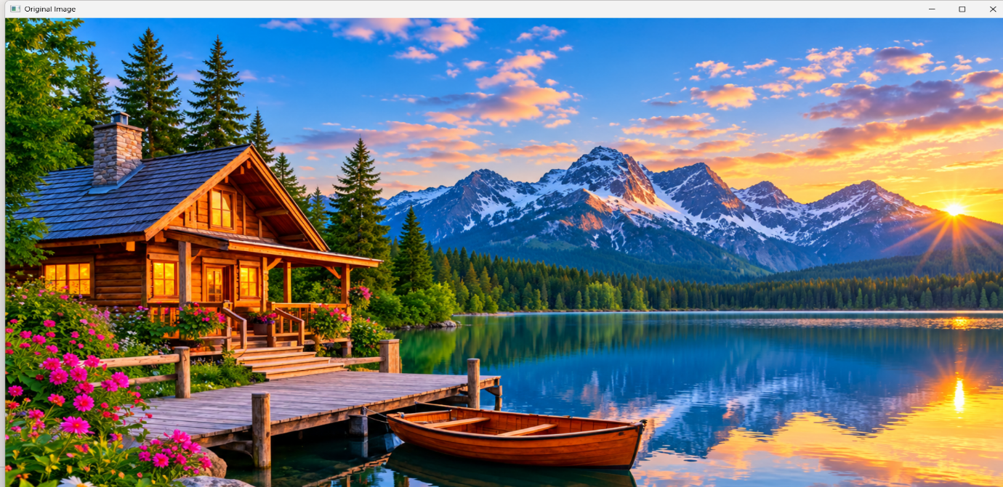
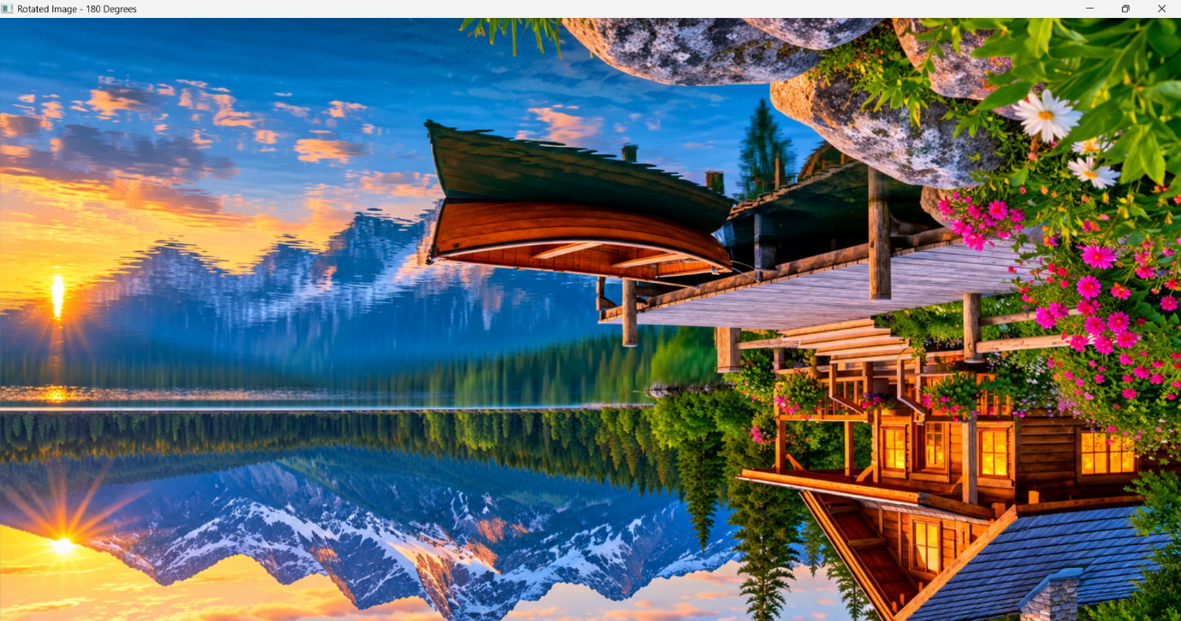

RESULT
Thus, the given image was successfully rotated by 180 degrees clockwise using Python and OpenCV.

